NAME: G. Yashmita REG NO: 192511032
(Git/Github)
EXPERIMENT 25:
Create a new GitHub repository for a personal project. Initialize the
repository with a README.md file. Then, clone the repository to
your local machine, make some changes to the README.md (e.g.,
add a project description), and push the changes back to GitHub.
Tasks:
- Create a GitHub repository.
- Clone the repository to your local machine.
- Edit the README.md file.
- Stage, commit, and push your changes to GitHub.

Aim
To create a GitHub repository, clone it to the local machine, modify the README.md file, commit the changes, and push them back to GitHub.
Software Requirements
- GitHub Account
- Git (Latest Version)
- Visual Studio Code
- Internet Connection
- Windows Operating System
Procedure

Step 1:

Create a GitHub Repository
- Open the GitHub website and sign in.
- Click the + icon and select New repository.
- Enter the repository name PersonalProject.
- Add a description (optional).
- Select Public visibility.
- Check Add a README.md file.
- Click Create Repository.
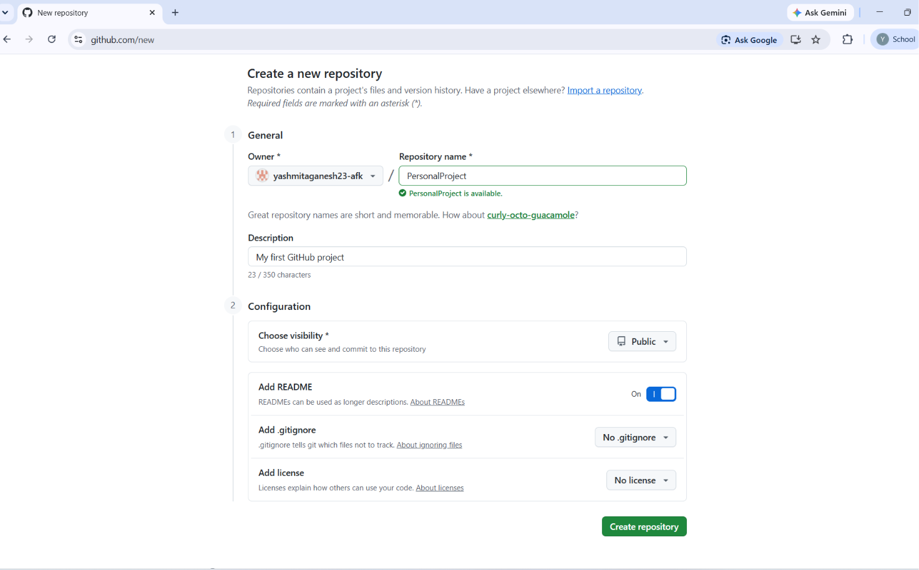
Figure 1: Creation of GitHub Repository

Step 2:

Copy Repository URL
- Open the created repository.
- Click the Code button.
- Copy the HTTPS repository URL.
Example:
https://github.com/username/PersonalProject.git

Step 3:

Open VS Code
- Launch Visual Studio Code.
- Open Terminal → New Terminal.
Step 4:
Navigate to the Desired Folder
Type:
cd Documents

Step 5:

Clone the Repository
Execute:
git clone https://github.com/username/PersonalProject.git
After successful cloning, move into the project folder:
cd PersonalProject
Open the project:
code .

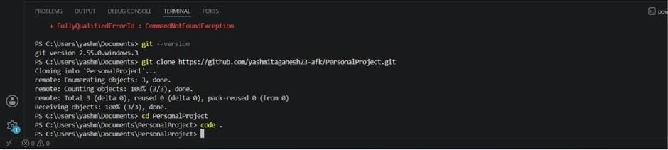
Figure 2: Cloning the GitHub Repository

Step 6:

Edit the README.md File
- Open README.md.
- Add the project description.
Example:
# PersonalProject

This is my first GitHub project.

This project demonstrates basic Git and GitHub operations such as cloning, editing files, committing changes, and pushing them to GitHub.
Save the file.
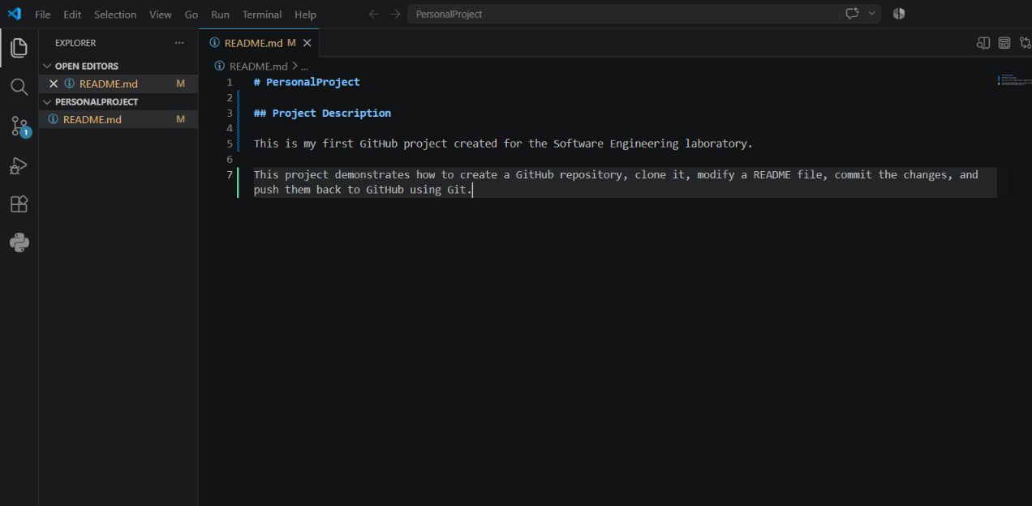
Figure 3: Editing the README.md File

Step 7:

Check Repository Status
Execute:
git status

Step 8:

Stage the Changes
Execute:
git add README.md

Step 9:

Commit the Changes
Execute:
git commit -m "Updated README with project description"

Step 10:

Push the Changes
If the branch name is main:
git push origin main

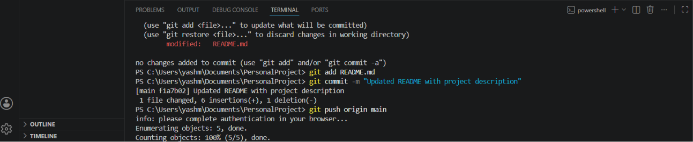
Figure 4: Committing the Changes

Step 11:

Verify
- Refresh the GitHub repository.
- Verify that the updated README.md file appears in the repository.
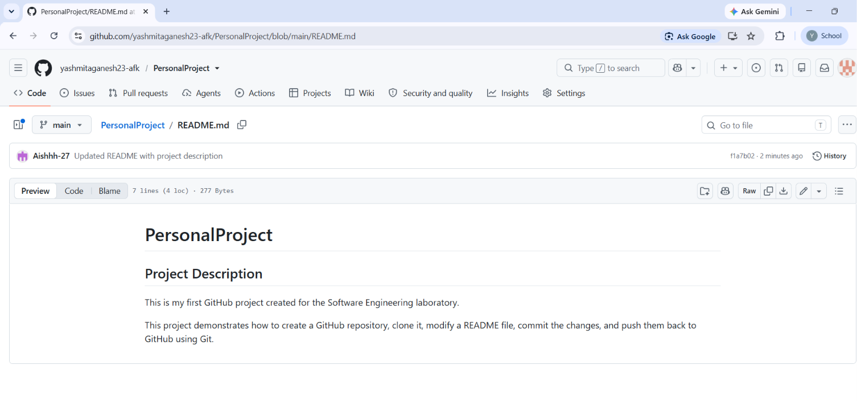
Figure 5: Updated GitHub Repository After Push

Commands Used
cd Documents
git clone https://github.com/username/PersonalProject.git
cd PersonalProject
code .
git status
git add README.md
git commit -m "Updated README with project description"
git push origin main

Result
Successfully created a GitHub repository, cloned it to the local machine, modified the README.md file, committed the changes, and pushed the updated repository to GitHub.

